Lab 2

Source Code and Output

To use getchar and putchar
#include <stdio.h>
#include <stdlib.h>

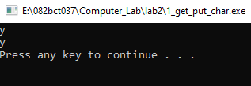
int main()
{
char ch = getchar();
putchar(ch);
putchar('\n');
system("pause");
return 0;
}

To use gets and puts
#include <stdio.h>
#include <stdlib.h>

int main()
{
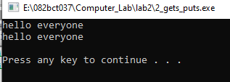
char str[20];
gets(str);
puts(str);
putchar('\n');
system("pause");
return 0;
}

To calculate KE and PE
#include <stdio.h>
#include <stdlib.h>

int main()
{
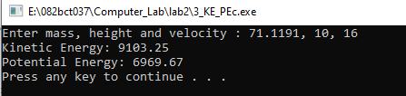
float m, ke, pe;
int h, v;
float g = 9.8;

printf("Enter mass, height and velocity : ");
scanf("%f, %d, %d", &m, &h, &v);

ke = 0.5 * m * v * v;
pe = m * g * h;

printf("Kinetic Energy: %.2f \nPotential Energy: %.2f \n", ke, pe);
system("pause");
return 0;
}

To display formatted outputs
#include <stdio.h>
#include <stdlib.h>
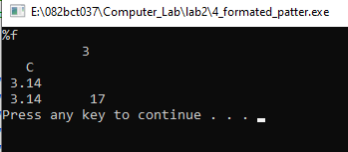
int main()
{
printf("%%f\n");
printf(" %10d\n", 3);
printf(" %3c\n", 'C');
printf(" %.2f\n", 3.14);
printf(" %.2f%8d\n", 3.14, 17);
system("pause");
return 0;
}

